*Preliminary* results of cover crop weed reduction analysis

March 20-21, 2018

248 observations

115 of weed density (~29 that have zeros for the cover crop treatment which does allow for a response ratio calculation)

**59% of response ratios are negative, meaning reduced weed density with a cover crop**

121 of weed biomass (same problem with the zeros here)

**67% of response ratios are negative, meaning reduced weed biomass with a cover crop**

Overall distribution

Cover crop biomass by density and weed biomass

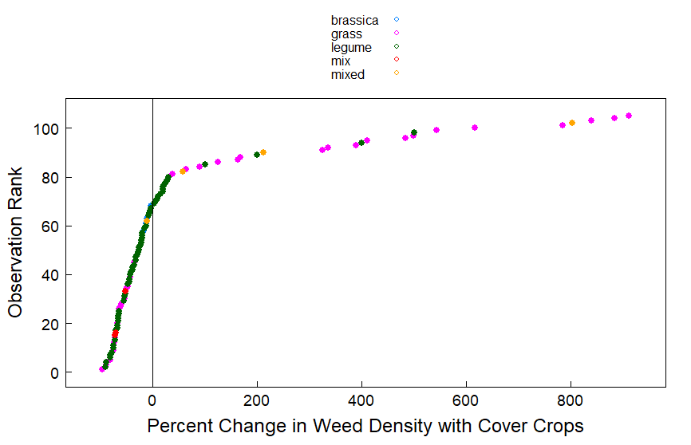

There are also some more large outliers in this… on the positive end meaning LARGE weed density increases with cover crops. We should investigate some of these studies.

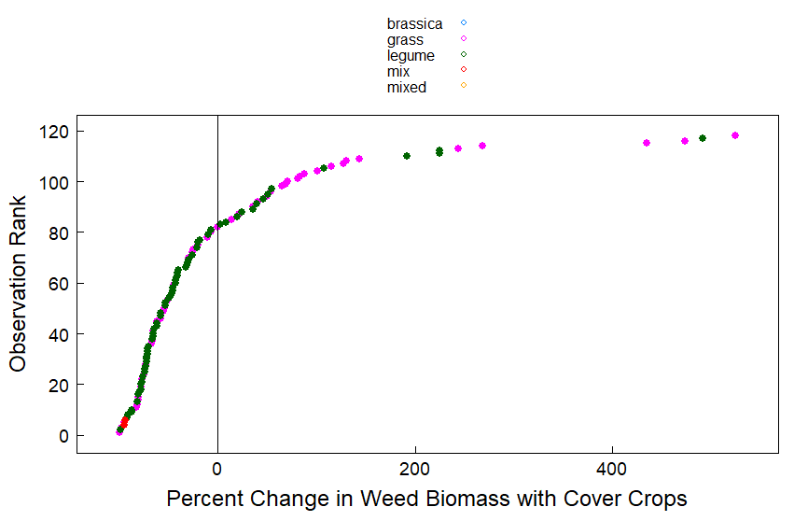

This data seems a little cleaner to me but still a trend with some very high increases in weeds with cover crops. Why?

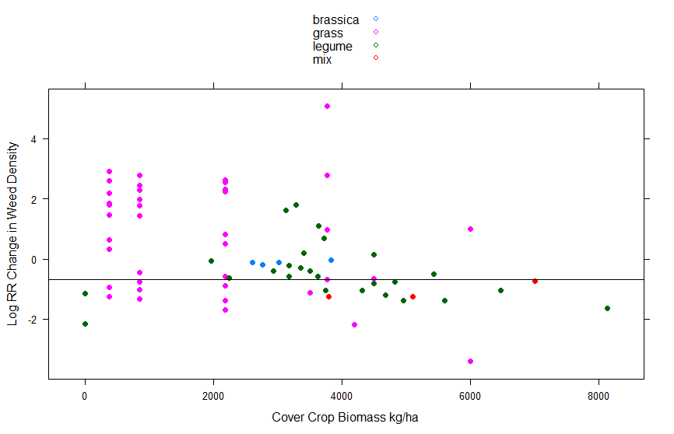

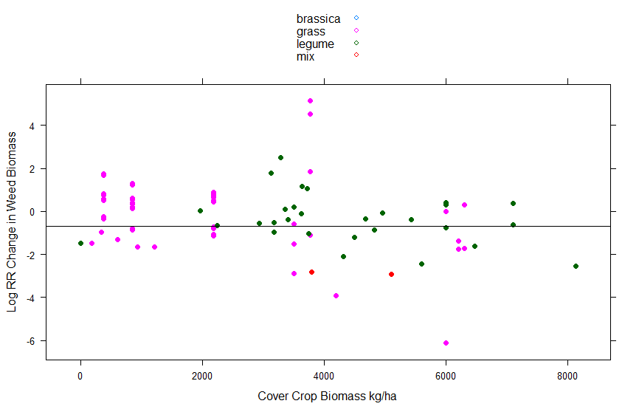

The figures for cover crop biomass and weed density/weed biomass are not super clean. There is some pattern (I think) with more grass biomass leading to more weed control. I added a line at -0.69 which is the LN of 0.5 noting a 50% reduction in weed control. Drawing a value from that is a little difficult. We could consider evaluating the regression coefficients to come up with a number for biomass but I think we’re pretty far away from being able to say anything concrete yet.

Also the studies with the same amount of biomass and negative and positive response ratios is confusing to me. What’s causing this?

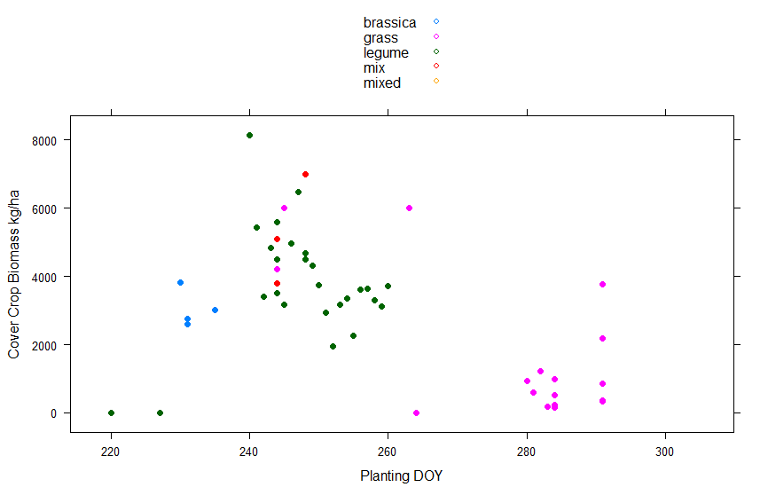

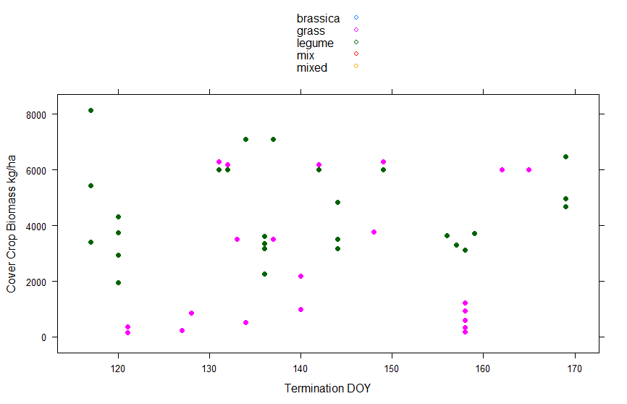

I don’t see clear patterns with planting DOY and termination DOY here either.

“win win” graph

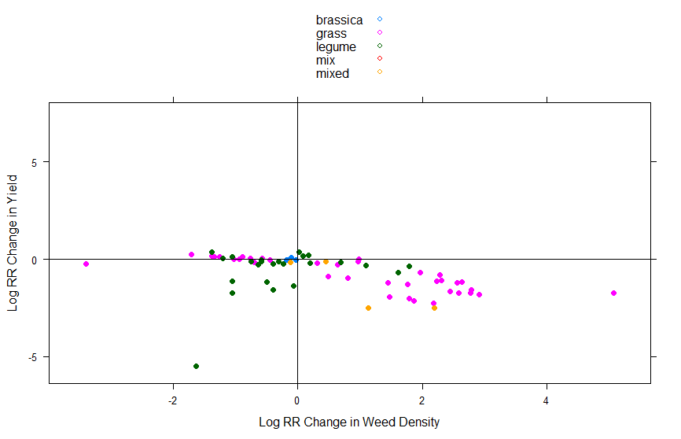

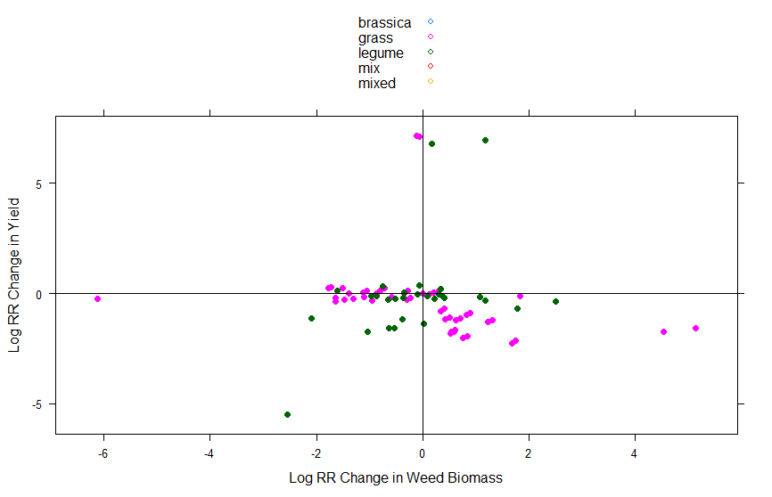

Comments/questions

Excluding the interseeding study – thought maybe that had been removed – should we take any of the others out. Right now we have 12 legit studies included.

Should we combine the two response ratios?

I haven’t done anything yet with the weighting. If they all have four reps then it isn’t going to do much for us to use reps as a weighting factor.

The variables that I added – only in the csv file

Study #

Month no. for planting date

Julian DOY for planting and termination dates – we should talk more about QC for this. Some of the dates did not have years so I defaulted to 2018. Unless this was a leap year that is an OK assumption but we may have days that are off by 1 DOY. I also did the conversion in excel which made it a little wonky (I could only get the formula to work by adding the year which I then had to text to column separate to remove)

Term method 2 – herbicide, mechanical, dual (mowing + herbicide), winter

We could ungroup some of the M categories but we need to be more standardized in that column